CoreDNS and CNI
What is CoreDNS

CoreDNS is a server written in Go, that provides a flexible plugin to listen for DNS requests coming in over UDP/TCP traffic. It serves as DNS for a cluster and must be installed via the CoreDNS GitHub project here.

CoreDNS is a complete solution for DNS resolution of internal hosts that make it easy to manage while still providing security capabilities to the entire network.

All DNS services are run in the kube-system namespace. In order to view CoreDNS and its predecessor Kube-DNS execute the kubectl get all -n kube-system command.

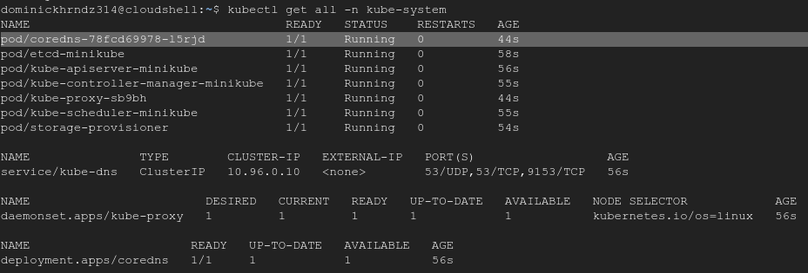
Alternatively you can also search for CoreDNS specifically with the kubectl get cm coredns –n kube-system command.

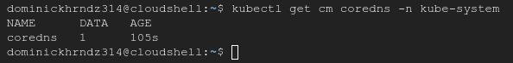
CoreDNS vs Kube-DNS
CoreDNS runs on a single container per instance, vs kube-dns which uses three. Kube-DNS uses single threaded caching vs CoreDNS, which is multi-threaded since its written in Go. This simply means that CoreDNS can open multiple connections and measure the speeds across them simultaneously.
Hands on – View and Modify the CoreDNS config file

I. View the core file:

The core file for CoreDNS is a ConfigMap with a section that defines CoreDNS behaviors. You cannot modify the file directly so we must create our own ConfigMap to overwrite the settings. Start by viewing the core file.

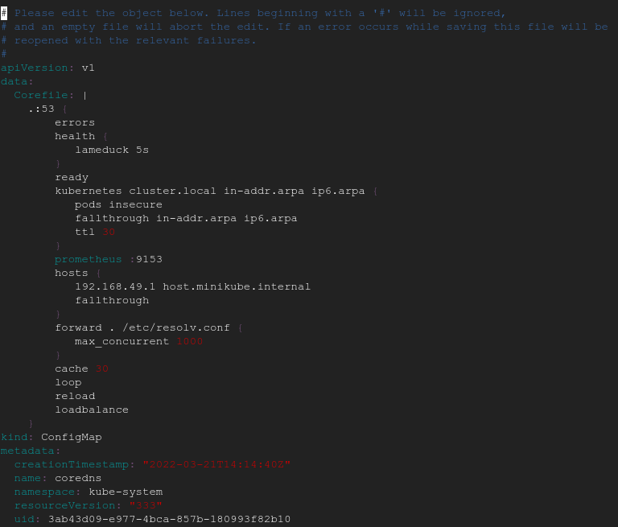
II. Create the ConfigMap:

We need to create a new config map and then apply it to the cluster. Once that’s done we can verify everything was created and then force our new Configmap to overwrite the old core file, by restarting the pod.

To restart a pod, simply delete the pod. Once this is done, check the kube-system namespace to verify that your new CoreDNS pod is running and Kube-DNS is not.

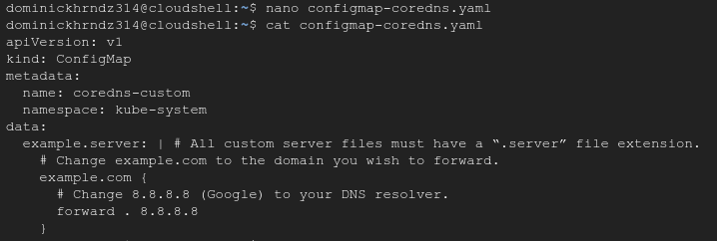
Now restart the pod.

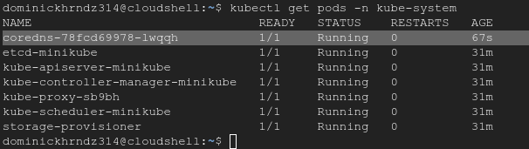
All Google requests to their 8.8.8.8 public IP will now be forwarded via the CoreDNS service. If you’re deployment is running you have completed this part of the training.

What is Container Network Interface

In Kubernetes, networking is one of the central components, providing connectivity between pods within the same host and across hosts. To make networking easier, Kubernetes uses CNI to provide a unified interface for interaction between containers.

There are several CNI implementations, many of which are available as open source CNI ‘plugins’.

These CNI plugins are apart of the pod network which includes one or more containers and a CNI plugin for each node. When configured, the containers connect dynamically to establish a network between pods and nodes.

For more information on CNI in GCP, please read the following articles:

https://medium.com/cloudzone/gke-networking-options-explained-demonstrated-5c0253415eba

https://medium.com/thermokline/how-to-choose-a-k8s-cni-plugin-771edf4842c0

